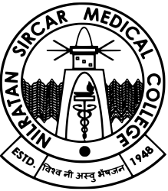

Government of West Bengal

Office of the Principal

Nil Ratan Sircar Medical College

Kolkata-700014

**Name of the faculty**: DR. MAUMITA DE

**Present Designation**: Assistant Professor, Department of Community Medicine

**Details of place of posting under WBMES**:

|  |  |  |  |
| --- | --- | --- | --- |
| **Position** | **Name of the Institution** | **From** | **To** |
| Demonstrator | Nil Ratan Sircar Medical College | 21/08/2015 | 19/11/2016 |
| Assistant Professor | Malda Medical College | 21/11/2016 | 28/08/2021 |
| Assistant Professor | Nil Ratan Sircar Medical College | 31/08/2021 | Till date |